**Project 7 Coin Detection with OpenCV**

Name: Randy Fu Period:5 Date: 3/15

Did you name your file l071.cpp (Lower case L, then 071)? Yes

Did you use OpenCV to detect coins? Yes

Did you test your code on terminal/gnu linux in c++11? Yes

Does your application create imageCircles.ppm file? Yes

Does your application create imageCoins.ppm file? Yes

Does your code display on the screen and in results.txt a summary of your results? Yes

What functions/methods from OpenCV did you use?

Circle

Mat

Gaussian Blur

HoughCircles

Imwrite

Canny

Imread

HoughGradient

IMREAD_GRAYSCALE

__________________________________________________________________________________

What functions/methods from OpenCV did you experiment with but ended up not using?

Run your code (the same code you submit) on the 3 images I provided (easy, medium, hard) then paste here the following:

* The initial image ( the one I provided), the imageg.jpg, imagef.jpg, imageCircles.jpg , imageCoins.jpg you obtained running your code, copy paste here the content of your results.txt file your code created

1. For the easy image:

Command line including all parameter values used for this image:

./l071 -f coinsEasy.jpg -lt 80 -ht 100 -ct 130 -fR results.txt -minR 83 -maxR 130 -sC 0 -minDist 50

minR is minimum radius to be considered for a coin

maxR is maximum radius to be considered a coin

minDIst is min distance between coins.

Initial image:

imageg.jpg:

imagef.jpg

imageCircles.jpg:

imageCoins.jpg:

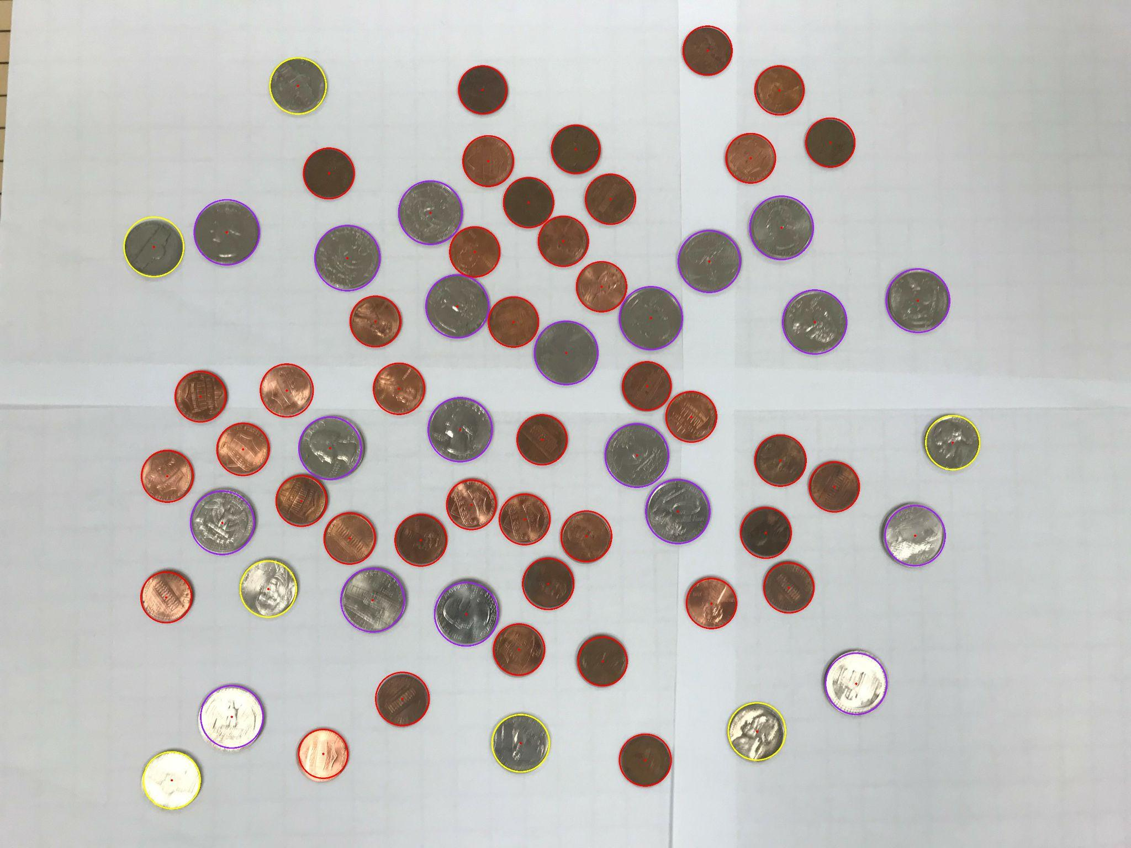

Content of results.txt:

41 pennies

7 nickels

0 dimes

20 quarters

0 half-dollar coins

0 dollar coins

Total Sum: $5.76

1. For the medium image:

./l071 -f coinsMedium.jpg -lt 80 -ht 110 -ct 150 -fR results.txt -minR 83 -maxR 130 -minDist 80

minR is minimum radius to be considered for a coin

maxR is maximum radius to be considered a coin

minDIst is min distance between coins.

Initial image:

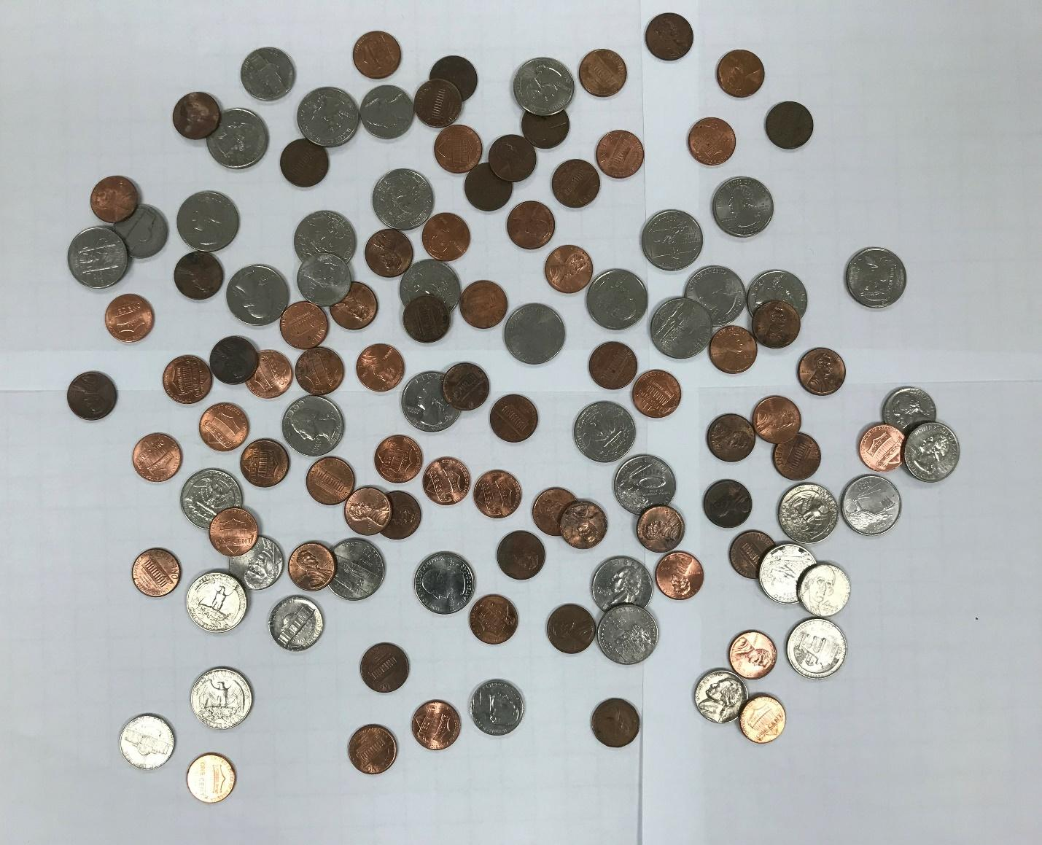

imageg.jpg:

imagef.jpg

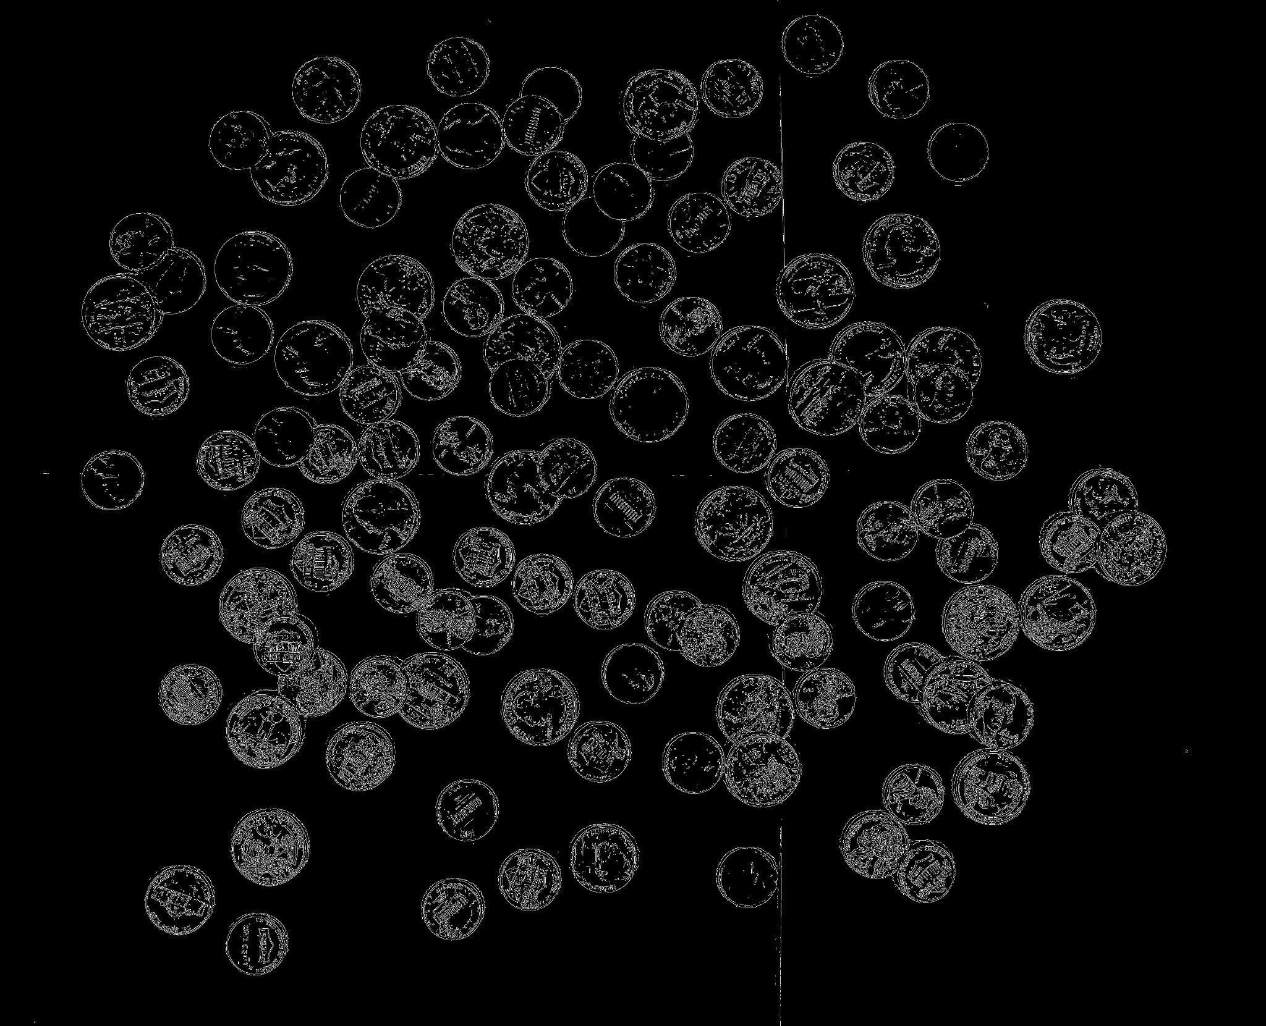

imageCircles.jpg:

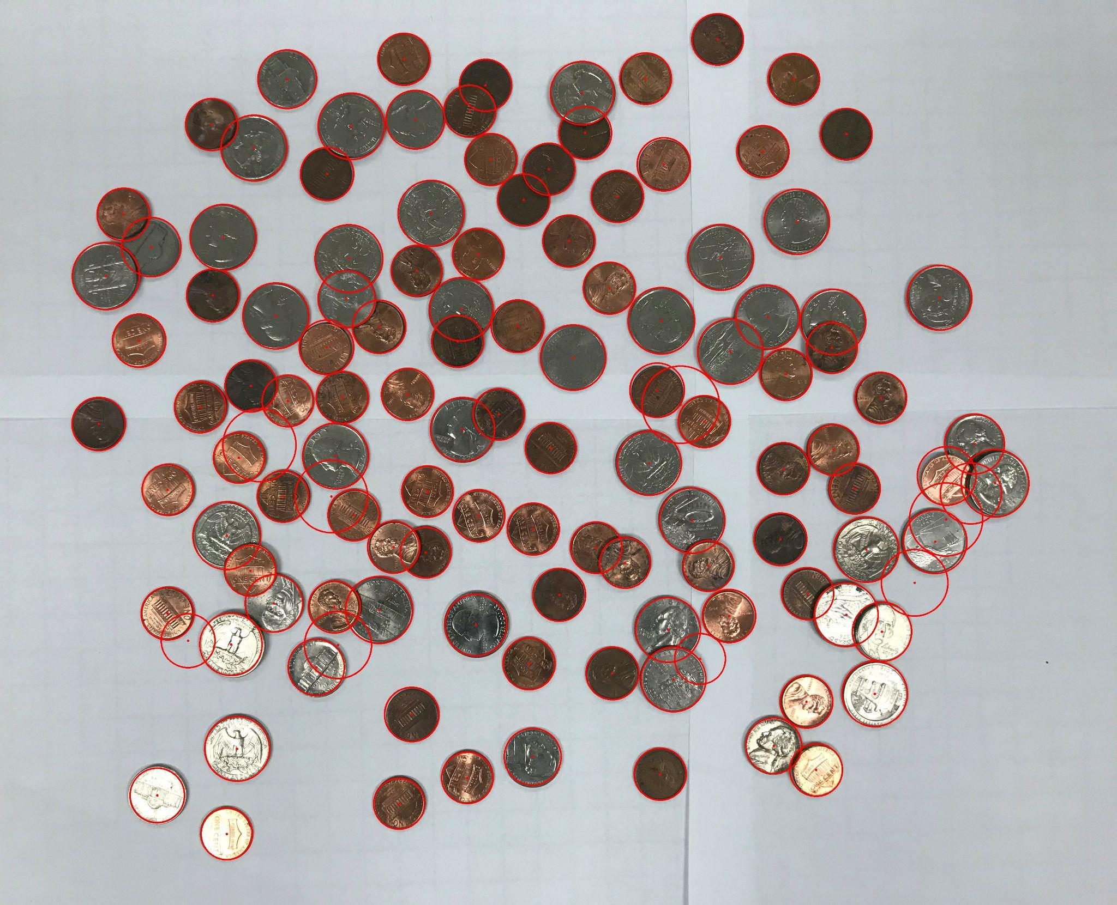

imageCoins.jpg:

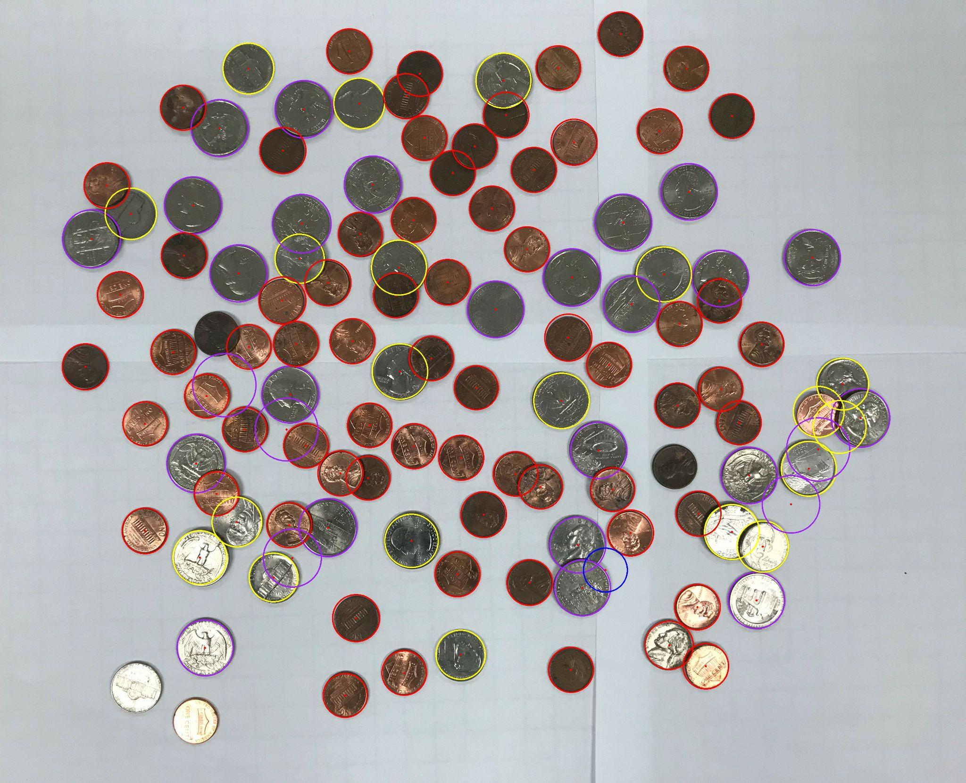

Content of results.txt:

69 pennies

20 nickels

1 dimes

29 quarters

0 half-dollar coins

0 dollar coins

Total Sum: $9.04

1. For the hard image:

Command line including all parameter values used for this image:

./l071 -f coinsHard.jpg -lt 80 -ht 120 -ct 180 -fR results.txt -minR 83 -maxR 130 -minDist 50

minR is minimum radius to be considered for a coin

maxR is maximum radius to be considered a coin

minDIst is min distance between coins.

Initial image:

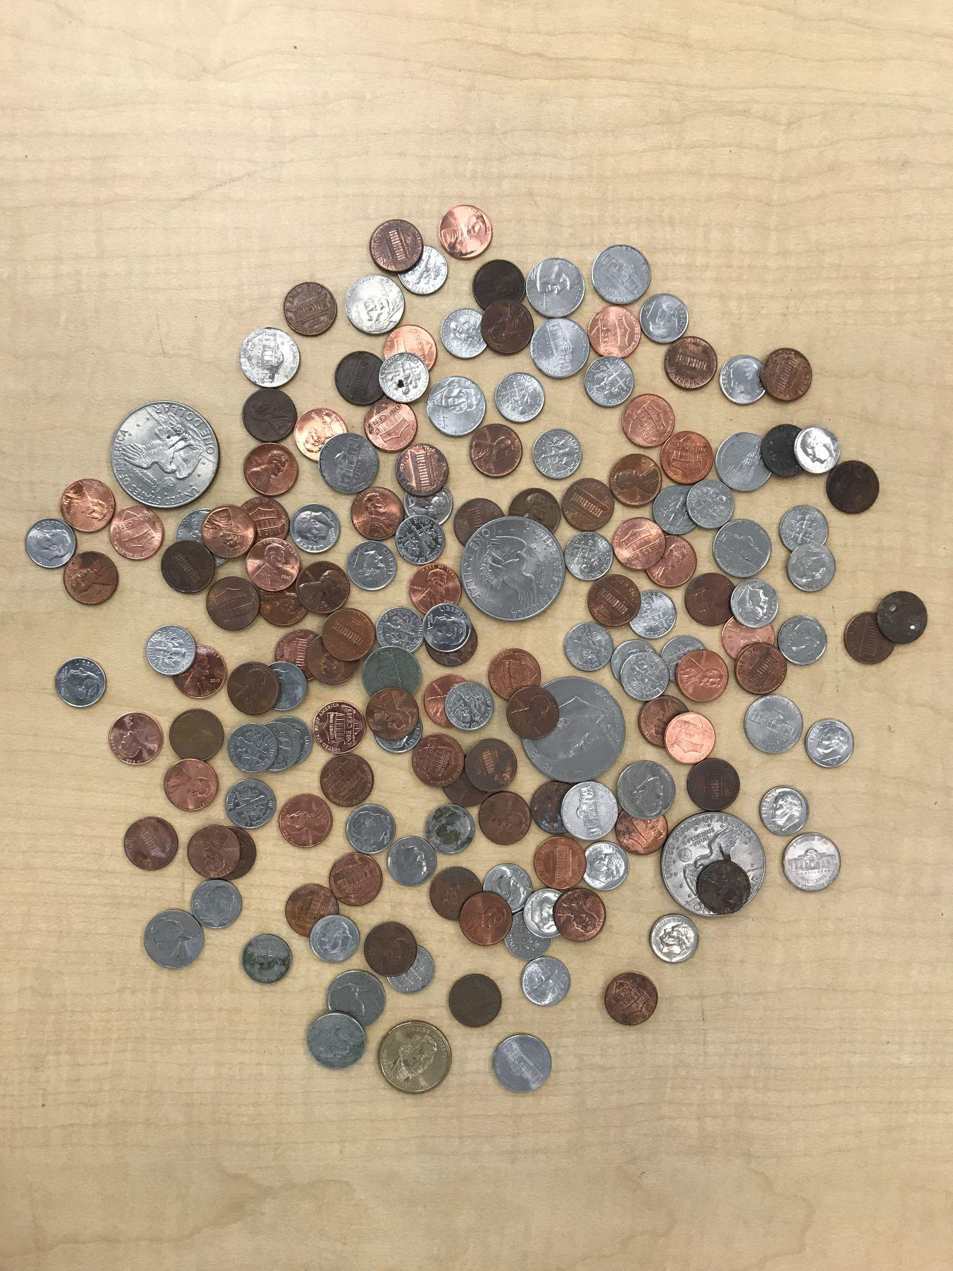

imageg.jpg:

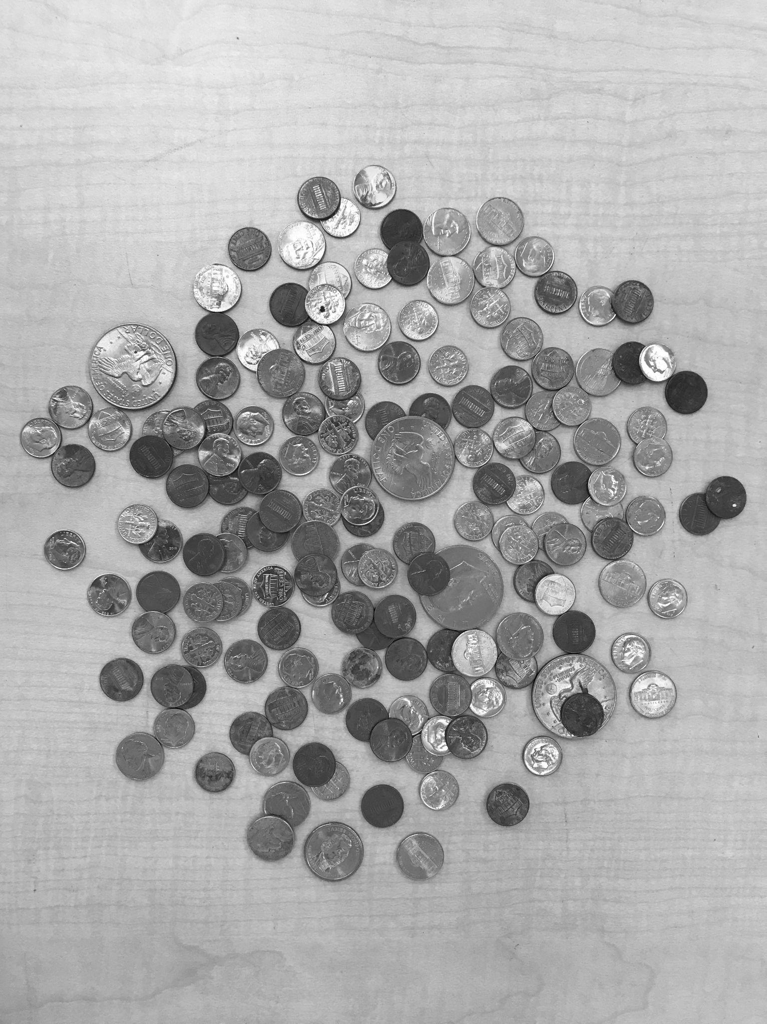

imagef.jpg

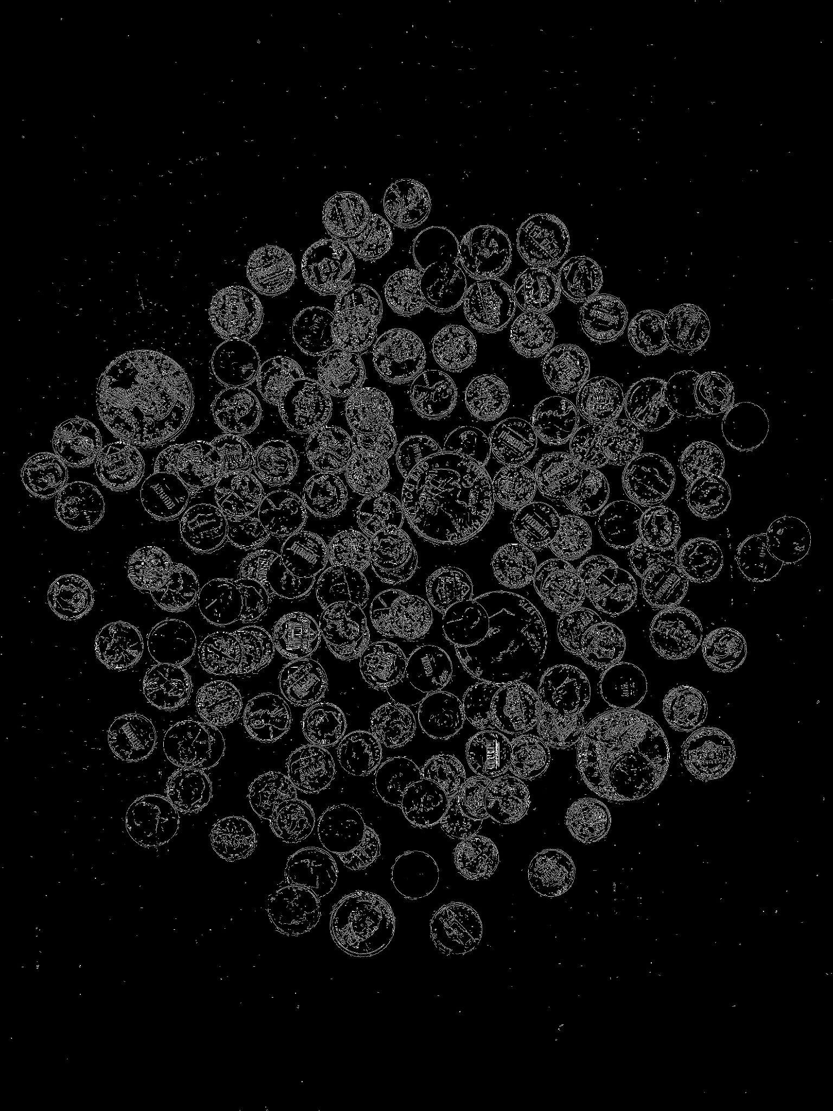

imageCircles.jpg:

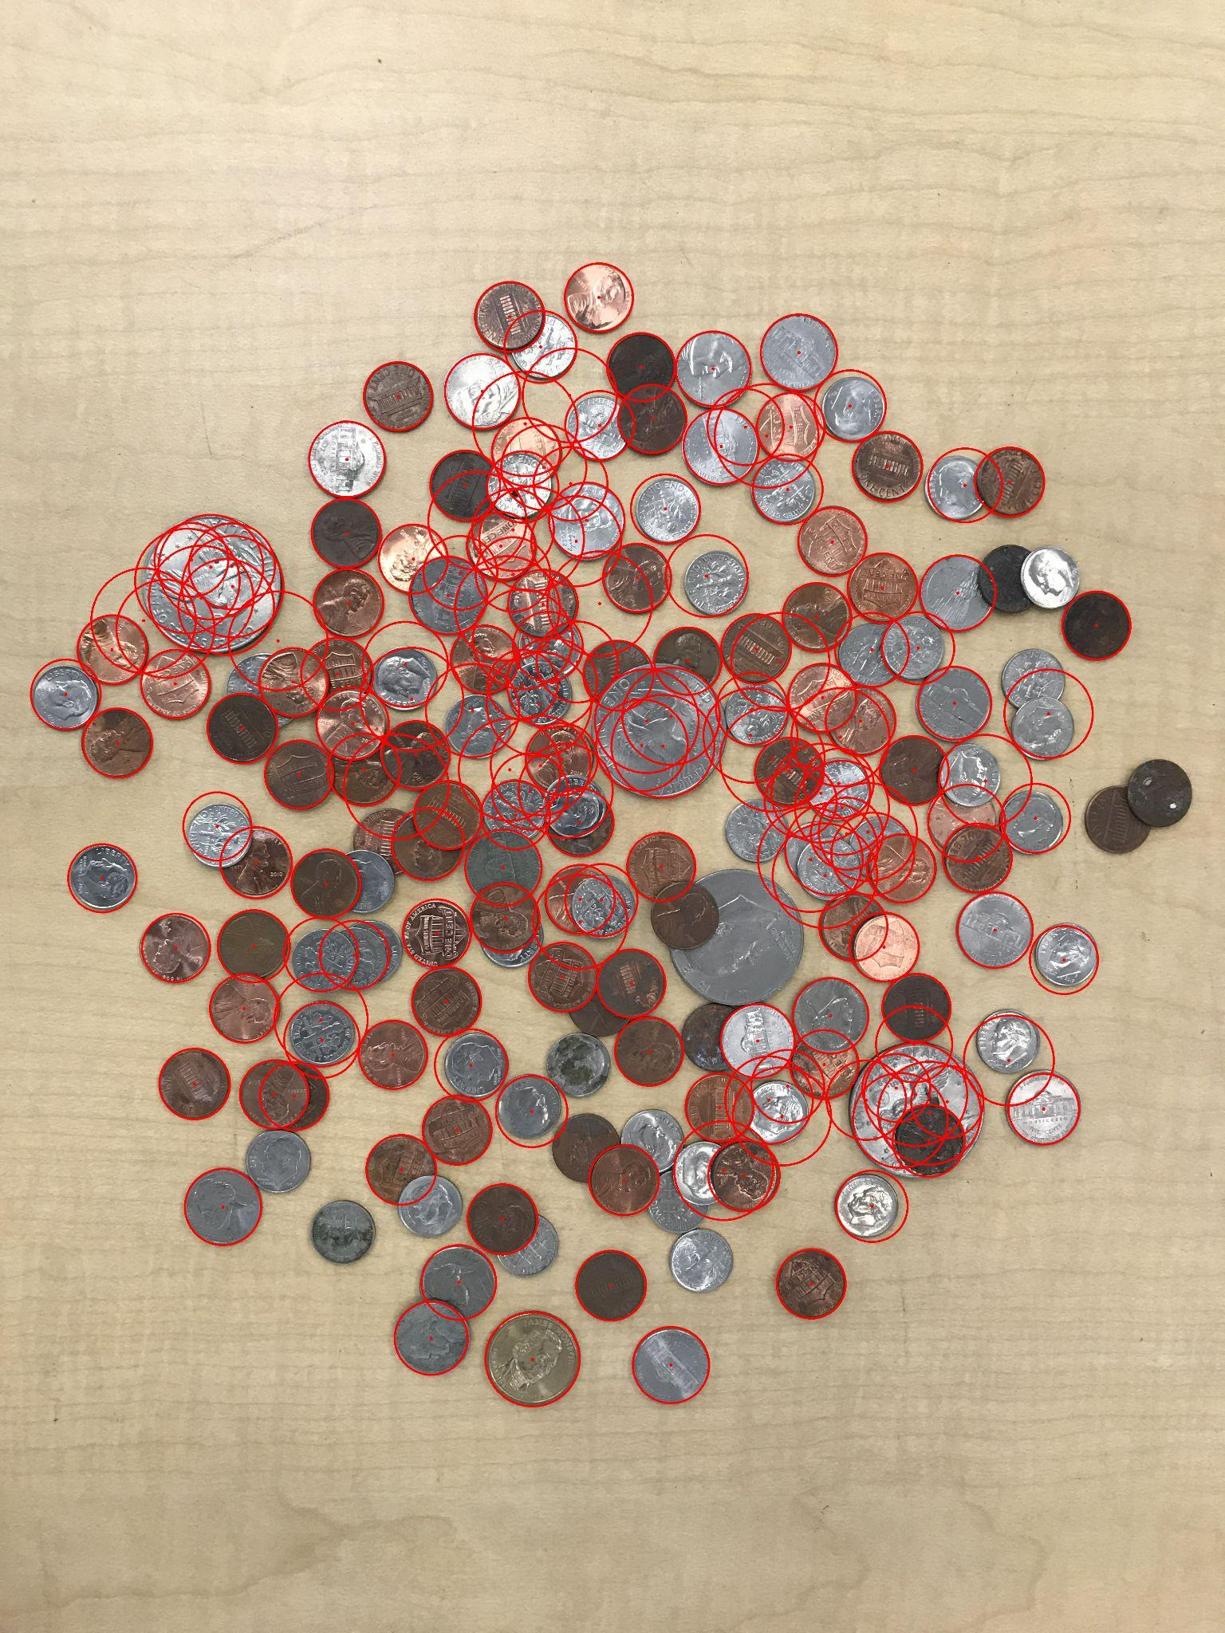

imageCoins.jpg:

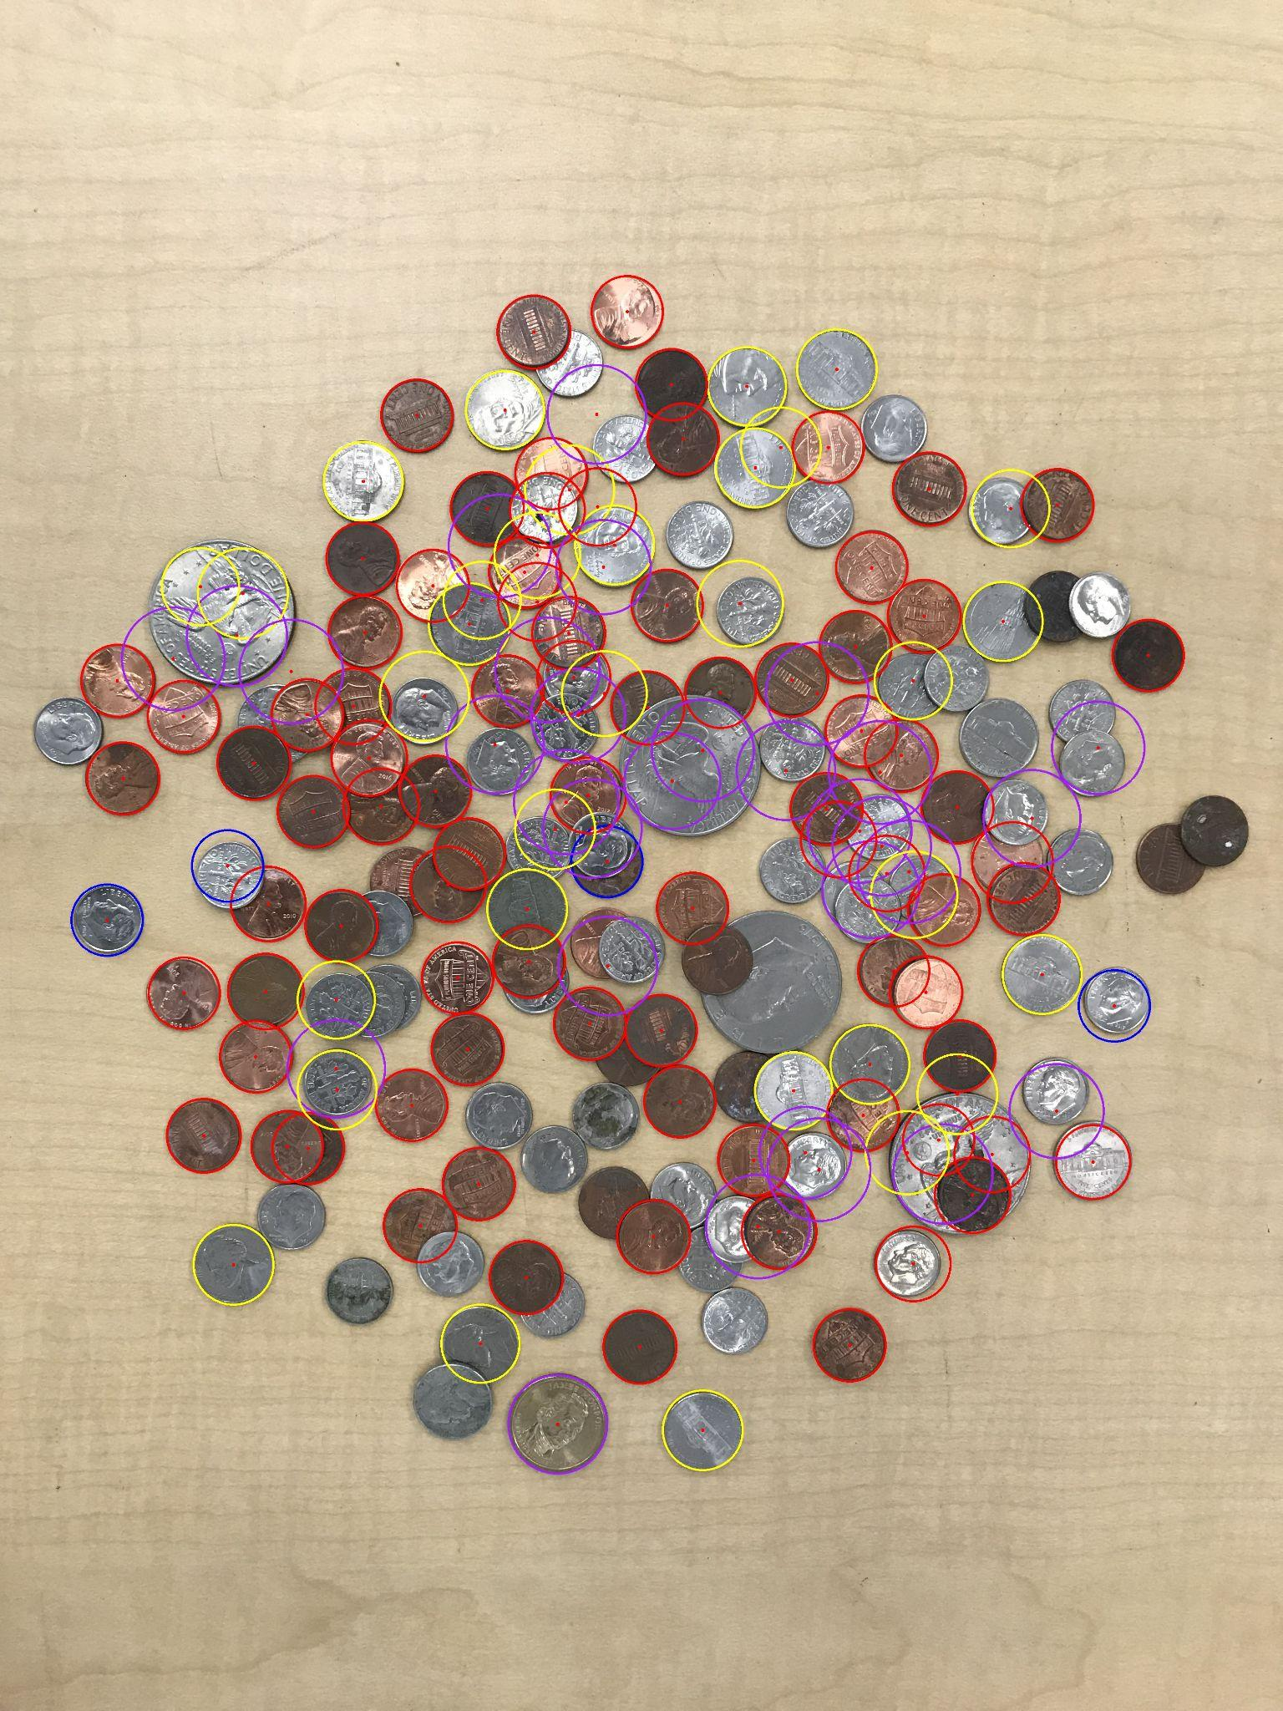

Content of results.txt:

83 pennies

32 nickels

4 dimes

30 quarters

0 half-dollar coins

0 dollar coins

Total Sum: $10.33